Weathering, Erosion and Deposition Scavenger
Name:

Introduction
The things we learn in school are meant to prepare you for the real world. “When am I ever going to need that,” you ask? Every day and all around you! Weathering, erosion and deposition are happening all the time at our houses, in our neighborhoods and in and around the streams in our community!

Part A: Apply Your Knowledge
Label the following images with what you know about weathering, erosion and deposition
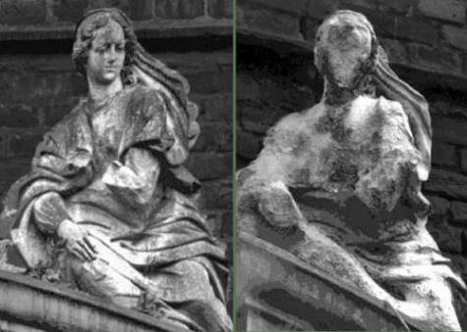  Sample | Example Answers for the Sample Image  Weathering, Erosion, or Deposition? Weathering  If Weathering, what type? Chemical  Agent? Weak Acid (Rain)  Process? Dissolution  Briefly describe what’s happening: The rain absorbs CO2, becoming a weak acid and melts/dissolves the statue.
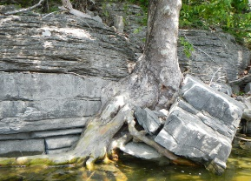 | Weathering, Erosion, or Deposition?  If Weathering, what type?  Agent?  Process?  Briefly describe what’s happening:
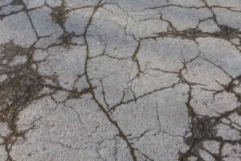 | Weathering, Erosion, or Deposition?  If Weathering, what type?  Agent?  Process?  Briefly describe what’s happening:
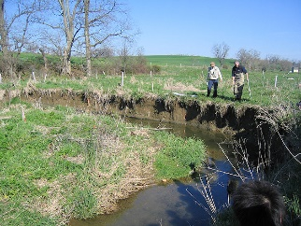 | (Hint: It’s a bend in a stream)  Weathering, Erosion, or Deposition?  If Weathering, what type?  Agent?  Process?  Briefly describe what’s happening:
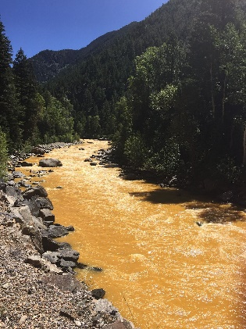 | (Hint: Dirty Water in the moving stream)  Weathering, Erosion, or Deposition?  If Weathering, what type?  Agent?  Process?  Briefly describe what’s happening:
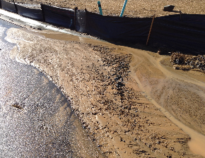 | (Hint: Dirt piles on the road)  Weathering, Erosion, or Deposition?  If Weathering, what type?  Agent?  Process?  Briefly describe what’s happening:

Part B: Scavenger Hunt!
Name:

Analyze Weathering & Erosion where you live!
- Take a photo of a different location for each item from your neighborhood (or around the local area.)
- Label each photo with a short descriptive title and which agent or process caused the result in the picture. (Using your phone’s social media or photo editing apps is an easy way to do this.)
- Paste your images to this table or upload the annotated images to drop box with Part A.
(Hint: Use your Lecture Graphic Organizers to help!)
Chemical Weathering | Mechanical Weathering
Erosion | Deposition
Cut Bank* | Point Bar*
Riffle* | Extra Credit:  A second (different) sample of any of the above.

*Note: The “Parts of a Stream” (Point Bar, Cut Bank, Riffle) can be seen in nearly ANY moving water! The images do not need to be of an active stream either! They can be seen where water once flowed but isn’t any longer!

